**Covid-19 Analysis**

**Name:** Janumpally Tejaswei

**Batch:** TE-BN002

**Project:** Covid-19 Analysis

* ***Objective***

To analyse the global impact of COVID-19 through a dynamic Power BI dashboard that provides interactive insights into the spread, severity, and control of the virus across countries over time.

* ***Tools & Technologies Used***

| **Tool** | **Purpose** |
| --- | --- |
| **Power BI** | Visualization, dashboard creation |
| **Power Query** | Data transformation and cleansing |
| **Microsoft Excel** | Data source for COVID-19 metrics |

* ***Data Source Description***

The dataset used in this project was sourced from a YouTube tutorial created by **Data Visionary**, titled *"* *Covid 19 Data Analysis | Real World Project | Power BI"*. The dataset was provided in the video description and originally designed for educational purposes. It has been adapted to better align with the scope and analytical goals of this project.

* **Video Title**: Covid 19 Data Analysis | Real World Project | Power BI
* **Channel**: Data Visionary
* **Platform**: YouTube
* **Date Accessed**: May 10, 2025

Any modifications made to the dataset include formatting adjustments, additional derived fields, and restructuring to support specific analysis within this project.

* Data includes:
  + Country/Region names
  + Date-wise data for:
    - Total cases
    - Total deaths
    - Total recovered
    - Total tests
    - Population

Data in Excel is used same and further cleaned in Power BI using **Power Query Editor**.

* ***Steps Performed***

1. **Data Import:**
   * Imported the Excel dataset into Power BI.
   * Checked for column types and missing values.
2. **Data Cleaning:**
   * Removed nulls and duplicates.
   * Selected the columns which are required and removed all the columns as there are many columns which are not required for the analysis.
   * Formatted date columns and standardized country names.
   * Filtered out irrelevant or incomplete records.

* ***Dashboard Design:***
  + Built multiple visuals including:
    - Total cases and deaths Country-wise Comparison.
    - Total cases and deaths Continent-wise Comparison.
    - New cases and deaths Continent-wise Comparison.
    - Total cases by country within a year.
    - Median age by Country and Continent.
  + Used slicers for:
    - Country
    - Continent
* Used Bookmark’s for Cases and deaths in Area chart, Pie Chart and Donut Chart.
* Used Cards for Population, Total Cases, Total Deaths and New Deaths.
* ***Visualization:***
  + Area Charts, Line Charts, Cards, Pie Charts, and Donut.
  + Color-coded cards and titles for easy understanding.
* ***Key Insights***

From the dashboard, users can identify trends such as

* Which country has high and low cases and deaths over a period of time
* How many new cases and deaths are happening?
* Which age group is mostly effected in the pandemic can be seen and also It supports understanding the global impact of COVID-19.
* ***Challenges Faced***

Some challenges included handling incomplete or inconsistent data, managing large datasets without compromising performance, and designing visuals that convey information clearly and concisely.

* ***Screenshots***
* **Total Cases by Country and Continent:**

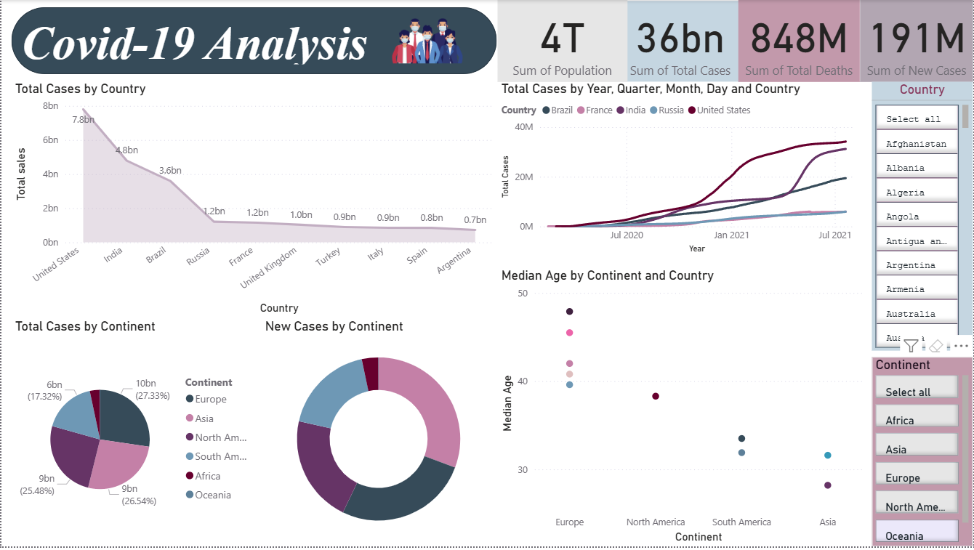

* **Total Deaths by Country and Continent:**

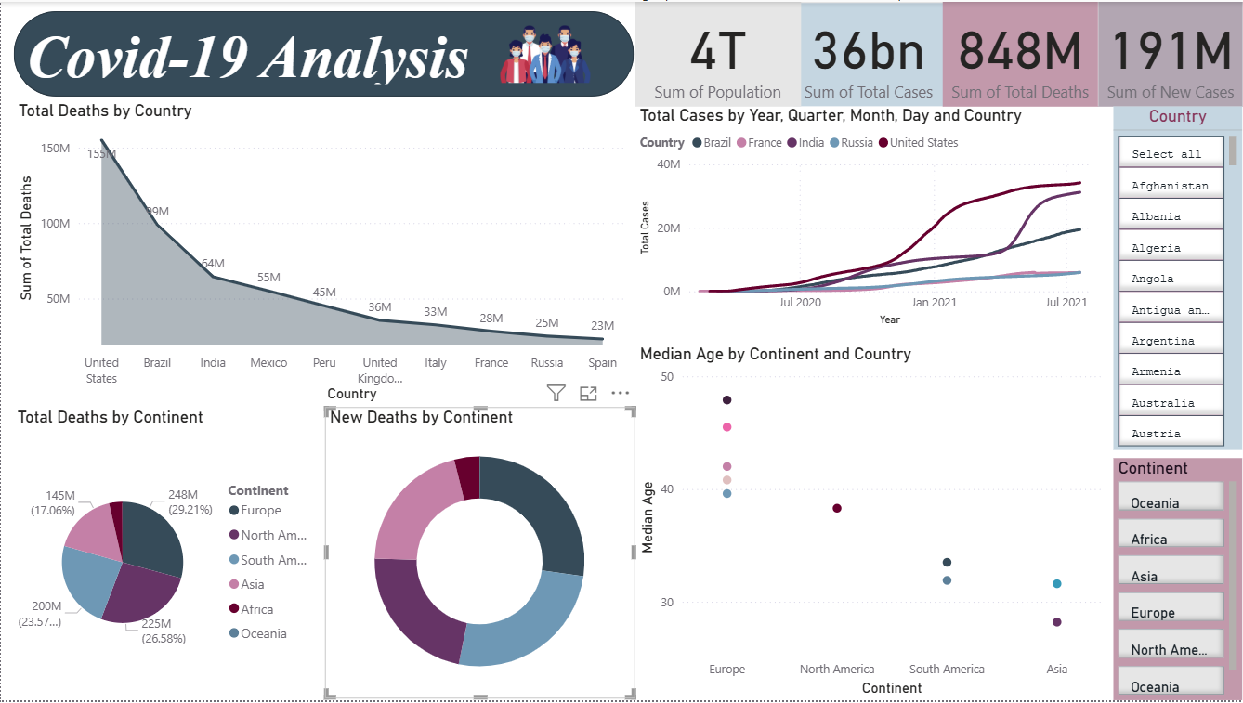

* ***Conclusion***

This project demonstrates how Power BI can be used effectively to visualize global health data. The dashboard allows for quick insights and supports data-driven decision-making during a public health crisis.